Equality Impact Assessment Form PM3 ID – 5802

DRAFT

Department | Transformation and Change | Version no | V0.3
Assessed by | Vicky Smith and Heidi Hardy | Date created | 17/11/23
Approved by | Gemma Emmett / Caroline Lee/ Joanne Conlon | Date approved | TBC
Updated by |  | Date updated
Final approval |  | Date signed off

The Equality Act 2010 requires the Council to have due regard to the need to
- eliminate unlawful discrimination, harassment and victimisation;
- advance equality of opportunity between different groups; and
- foster good relations between different groups

Section 1: What is being assessed?

1.1 Name of proposal to be assessed.

Contact Management Programme

1.2 Describe the proposal under assessment and what change it would result in if implemented.

The Contact Management Programme has been initiated as part of the Transformation and Change Portfolio to fundamentally change the way it delivers services by increasing organisational capacity and strengthen frontline services, allowing the Council to achieve better outcomes for its residents, businesses and communities. The programme will support a Council’s Digital Channel Shift Strategy for Contact Management.

Section 2: What the impact of the proposal is likely to be

  - Will this proposal advance equality of opportunity for people who share a protected characteristic and/or foster good relations between people who share a protected characteristic and those that do not? If yes, please explain further.

The proposal will advance equality of opportunity for all customers who currently access these services. The programme will give the customer improved choices for their preferred point of access to the council’s services.

Additional EIAs will be undertaken, for each digital platform within the Programme.

  - Will this proposal have a positive impact and help to eliminate discrimination and harassment against, or the victimisation of people who share a protected characteristic? If yes, please explain further.

Yes, all the businesses/system processes through Customer contact will be re-designed in an attempt to improve the quality of service provided to citizens within the district.

Any mitigation required such as training, policy change, advice and guidance will be recorded on the appropriate action log for each project and within the action log for this Assessment.

The Project Team have reviewed Bradford’s rich demographic dataset to understanding resident characteristics, trends and preferences to ensure these can be taken into consideration in future decisions around customer contact solutions (feeding into the business case for the development of the Customer Contact Programme).
The Programme Board and project teams will work closely with the Council’s Digital Inclusion Lead to review service redesign, and look for opportunities to support digital channels where this is not currently available for residents.

  - Will this proposal potentially have a negative or disproportionate impact on people who share a protected characteristic? If yes, please explain further.

No.

  - Please indicate the level of negative impact on each of the protected characteristics?

(Please indicate high (H), medium (M), low (L), no effect (N) for each)

Protected Characteristics: | Impact  (H, M, L, N)
Age | N
Disability | N
Gender reassignment | N
Race | N
Religion/Belief | N
Pregnancy and maternity | N
Sexual Orientation | N
Sex | N
Marriage and civil partnership | N
Additional Consideration:
Low income/low wage | N
Care Leavers | N

2.5 How could the disproportionate negative impacts be mitigated or eliminated?
(Note: Legislation and best practice require mitigations to be considered)

Not applicable.

Section 3: Dependencies from other proposals

3.1 Please consider which other services would need to know about your proposal and the impacts you have identified. Identify below which services you have consulted, and any consequent additional equality impacts that have been identified.

The programme will be in close liaison with all the service units to deliver the best service for the units and their clients. The Customer Contact Team will be included in training and development plans.

Section 4: What evidence you have used?

4.1 What evidence do you hold to back up this assessment?

The Project Team, in consultation with PwC, has undertaken an extended study throughout the service units to confirm opportunities to improve the customer journeys provided by the council.

4.6 Do you need further evidence?

No

Section 5: Consultation Feedback

5.1 Results from any previous consultations prior to the proposal development.

Previous consultation includes a staff May 2023 which informed the development of the Programme.

Voice Automation

PWC reviewed existing data to identify three potential areas for voice automation.
They estimated potential benefit ranges by applying our experience from other authorities.

PWC engaged with our ICT and service teams to verify the following high level assumptions:
- AWS Connect technology will be put at the end of your IVR, rather than replace your telephony.
- main contact centre systems is Civica 360
- main Revs & Bens software is Northgate.

In addition, it was assumed that:
- Capacity released through reduction in calls can be translated into cashable savings through FTE release / reduction
- No redundancy costs will be incurred due to staff turnover rates
- ICT capacity and capability is available to enable implementation, from systems and access to enabling go-live
- Procurement capacity is available to facilitate quick access to GCloud suppliers
- Call listening and analysis can be undertaken alongside your contact teams to refine the benefits case and go into detail around the types of calls received by the Council

Customer Contact

PWC found that our current contact management processes are fragmented, workflows have not been optimised and user experiences are inconsistent.
Based on similar work with other authorities, a possible 10-15% of baseline FTE effort can be saved through a combination of the following cost reduction levers. Based on an initial view of contact volumes, this would represent a ROI of 3:1, although further work to confirm volumes and types of contact was carried out to verify the assumptions.

5.2 The departmental feedback you provided on the previous consultation (as at 5.1).

The Head of Transformation and Change has provided updates as to the reasons for the changes to CMT and consultation will continue to take place during the Programme.

The Programme Manager will ensure that any projects within the Programme requiring specific changes/alignments to staffing structures within the respective service will ensure that the Trade Unions will be consulted as a part of this process.

5.3 Feedback from current consultation following the proposal development (e.g. following approval by Executive for budget consultation).

It is proposed that consultation with representatives from service users from will be managed through the individual project boards within the programme. In additional all staff and service users will be included in any consultation.

5.4 Your departmental response to the feedback on the current consultation (as at 5.3) – include any changes made to the proposal as a result of the feedback.

The Transformation and Change Programme Manager will attend the Customer Contact Programme Board and will provide regular formal updates through the programme on any issues arising from consultations taken / taking place as a result.

Greater scrutiny of functional and non-functional requirements from both the staff and citizen user perspective to ensure the Council is procuring goods and services that uphold and support the Public Sector Equality Duty and that delivery planning is done in conjunction with staff led groups who can inform and support optimum results for the transition on the technology being implemented as part of this Business Case.

There is a need for a Customer Charter for Customer Contact to be produced that meets the needs of all users with protected characteristics.

A robust Communications Strategy will be implemented during the life cycle of the programme.

APPENDIX A: Full Details of the EqIA

Section 1: What is being assessed?

1.1 Name of proposal to be assessed.

Contact Management Programme

1.2 Describe the proposal under assessment and what change it would result in if implemented.

The Contact Management Programme has been initiated as part of the Transformation and Change Portfolio to fundamentally change the way it delivers services by increasing organisational capacity and strengthen frontline services, allowing the Council to achieve better outcomes for its residents, businesses and communities. The programme will support a Council’s Digital Channel Shift Strategy for Contact Management.

The proposed Business Case for Contact Management will not result in the cessation of any of the services provided but will instead provide an optional method of digital service request for residents who will be able to self-serve.

Service users and wider community: increased flexibility and choice in how to contact/interact with the Council to resolve queries, issues or service requests through the broadening of contact channels in the new contact centre solution. This could be through any or all of the following channels: telephony, SMS, email, social media, web chat, bot or by starting the contact on one channel and being given an option to change to a different channel mid contact. Modernising CBMDC’s range of contact channels as well as maintaining traditional channels for those who prefer to use them through the replacement contact centre solution either out of choice or necessity. The contact channels available through the contact centre solution will complement other existing channels such as face-to-face and digital self-service.

As part of the work of establishing the “as is” position, PWC carried out a series of conversations across a range of services across the Council identified through from data provided by the Contact Centre, Adults Social Care and administration offices. Process mapping of the “as is” and “to be” processes and user journeys has taken place providing a clear benchmark for establishing and prioritising the projects within the programme.
The planned programme of work will be developed with both services and residents/customers/users and will deliver the following organisational and customer change.

External Contact channel shift and automation

By improving the External contact channel and introducing further automation for our citizens and service users, the council will further accelerate the digital channels and increase the consistency for users and may release £165- £140K cashable savings.

Contact process improvement

A review of all the design end-to-end user journeys is required to ensure efficiency to minimise handovers and reduce administrative burden, this may realise £330-490K cashable savings.

Reduce avoidable contact demand

By reducing demand for initial enquiries and simple assessments by improved self-service and triage following the review and implementation of end-to-end user journeys this may release £340K cashable savings.

The Customer Contact Programme sets out to deliver effective change through:

- Make better use of resources through ensuring contact agents and teams are able to manage contact in a consistent way whilst problem-solving. This work would identify priorities for consolidating contact.
- Channel shift: The implementation of end-to-end digital journeys, and a front door and pre-front door which signpost and triage efficiently. This work would accelerate the development of digital journeys, ready to build.
- Improve processes and reduce avoidable demand: A single view of the user which reduces manual effort between systems and users having to repeat themselves. This work will inform the business case for Contact Management for creating a single view of the user.

Channel shift can impact on specific service access issues for various equality strands. The process of developing and implementing a channel shift strategy needs to be guided by insight specifically relating to:

The customer, including equalities access issues (such as plain English and text size).
The services an organisation provides and each service area in question.

The current delivery channels at the organisation’s disposal, as well as those that may be available to be / need to be used in future. It is also important to bear in mind:

- The target audience’s access to technology.
- The type and complexity of the contact.
- The skill sets of individual service users.

Online access to services is a very effective channel with considerable benefits for customers, as they can be easy and quick to use and available whenever customers need them.

Online services are also beneficial to Bradford Council as they have a relatively low administrative cost when managed well. The public sector must also meet the needs of people who do not (yet) have access to the internet. ‘Digital Inclusion’ therefore is a core element of any government/public sector channel strategy.

Many older residents’ preferred method of contact remains face to face or in writing, and although more than half of pensionable people nationally are users of social media, this remains significantly lower than other age bands and the option of face-to-face contact will remain in place.

Section 2: What the impact of the proposal is likely to be

  - Will this proposal advance equality of opportunity for people who share a protected characteristic and/or foster good relations between people who share a protected characteristic and those that do not? If yes, please explain further.

The proposal will advance equality of opportunity for all customers who currently access these services. The programme will have their point of access changed through digital channels, as a result of the expanded front door, as well as those who chose to telephone the contact centre in order to access council services (as these services will largely move to digital platforms).

Yes, it will improve all business/core system processes across the Council which will in turn result in an improved Customer Experience for our customers at the point of access for these services, identifying opportunities at each stage of the journey to guide people towards online self-service, enabling customers who want, and are able to do so, to use self-service online at any time they wish regardless of their protected characteristic.

Additional EIAs will be undertaken, for each digital platform within the Programme.

  - Will this proposal have a positive impact and help to eliminate discrimination and harassment against, or the victimisation of people who share a protected characteristic? If yes, please explain further.

Yes, all the businesses/system processes through Customer contact are being re-designed to improve the quality of service provided to citizens within the district.
Any mitigation required such as training, policy change, advice and guidance will be recorded on the appropriate action log for each project and within the action log for this Assessment.

The Project Team have reviewed Bradford’s rich demographic dataset to understanding resident characteristics, trends and preferences to ensure these can be taken into consideration in future decisions around customer contact solutions (feeding into the business case for the development of the Customer Contact Programme).
The Programme Board and project teams will work closely with the Council’s Digital Inclusion Lead to review service redesign, and look for opportunities to support digital channels where this is not currently available for residents.

Section 3: Dependencies from other proposals

3.1 Please consider which other services would need to know about your proposal and the impacts you have identified. Identify below which services you have consulted, and any consequent additional equality impacts that have been identified.

The programme will be cross cutting through the council and regular communications will be undertaken internally and externally. During the Programme initiation a communication strategy will be undertaken to identify all stakeholders who will be involved. The Project Team spent ten weeks with the following teams: Customer Services (visible services including waste, clean air, parking, housing options and housing benefits), Council Tax and Adult Social Care in order to map 35 resident journeys. Listening directly to resident calls to understand common queries, the use of technology and opportunities for improvement.
The Project Team have also been running workshops and deep dives with Managers across the front and back office teams through the organisation to obtain demand data across all channels and review the end to end journeys.
We have undertaken a baseline to understand the FTE effort required to respond and service all contact activity across different resident journeys.
The IT requirements to support the Customer Contact Service will also ensure that any impact on protected characteristics.
As part of the Programme all training which is arranged will take into account protected characteristics. All training that may be required will ensure that where possible will that it just does not include sessions via Teams, user guides will be written and where appropriate super users for the system (regardless of their protected characteristic) will be available to support colleagues and users. The Customer Contact Team will be included in training and development plans.

Section 4: What evidence you have used?

4.1 What evidence do you hold to back up this assessment?

The Project Team has reviewed Bradford’s rich demographic dataset to understanding resident characteristics, trends and preferences to ensure these can be taken into consideration in future decisions around customer contact solutions (feeding into the Council owned business case).
At this stage we have carried out internal engagement with relevant teams and business partners, but further engagement is planned specifically with the Disabilities Network about how they would like to be involved in this. As part of the programme, we will be working closely with the Communications team to identify other forums for the organisation to be involved in and specifically residential forums we can consult with. This engagement will continue through the current Business Case stage and beyond into delivery to ensure we are fully aware of impacts and amendments required.

A range of functional and non-functional requirements will be included in the Business Case to ensure that we can best evaluate vendors on how they meet our needs, specifically in terms of staff groups with accessibility requirements for system/app use as part of their role, and for citizens to have a range of channel option to choose how to engage with the Council that best suits their needs. Any subsequent proposals which were likely to impact on workforce would be subject to staff consultation in accordance with our Managing Change Policy.

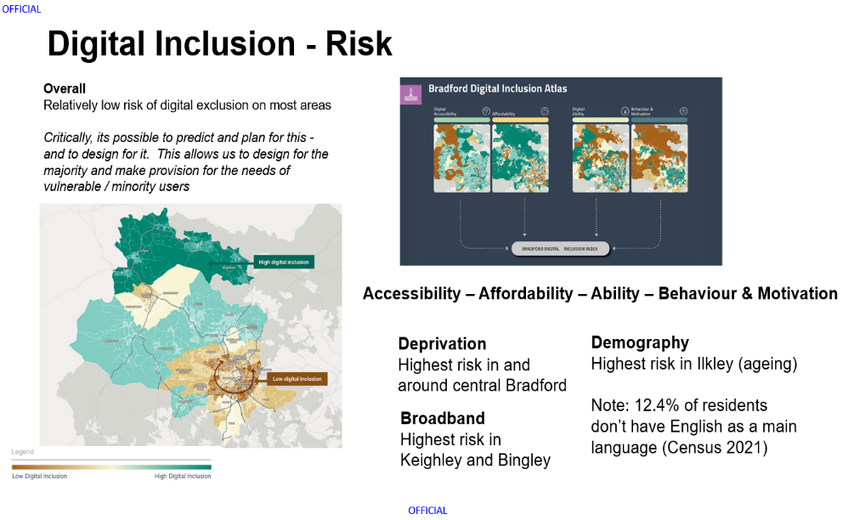

4.2 Impact of the proposals on residents and service users with protected
Characteristics

Protected characteristic | Potential positive impacts | Potential negative impacts | Evidence
Age | People who prefer to self-serve  will benefit from this policy. This  may include younger people.  A single point of access for all  council services will make it  easier for customers to access  the information and services  they need. | People who are digitally excluded will be impacted by this policy. This group may include older people.  Channel shift strategy towards digital offerings could be seen as impacting older people with less propensity to using these channels, however this proposal is not closing traditional contact channels such as telephony and face-to-face. | Data shows that almost all adults age 16-54 regularly use the  internet. This drops to 41% in those aged 75+.
Disability | None | People who are unable to self-serve may be impacted by this change. This group may include  people with certain types of disability.  However, face to face and postal service will remain in place.  Introduction of web-based channels such as IVR, bot, web chat may have an impact on staff with accessibility needs and those staff may not be able to incorporate those channels into their skill set, as well as being seen to be disadvantaging citizens who are unable to use these channels due to disabilities preventing their use.  Online services could present considerable cognitive demands. The multiplicity of passwords required was reported to be a major barrier, especially where people were not familiar with using technology. This appeared particularly challenging for participants with memory and learning, understanding or concentration impairments. | Latest data from ONS  states that 39% of adults with disabilities  aged 75+ used the internet recently  compared with 49% of non-disabled adults
Gender reassignment | None | None | None
Race | None | None | None
Religion/Belief | None | None | None
Pregnancy and maternity | None | None | None
Sexual Orientation | None | None | None
Sex | None | None | None
Marriage and civil partnership | None | None | None
Additional Consideration:
Low income/low wage | None | Access to technology to access new channels such as web chat, social media may be hindered disproportionately affecting people from deprived areas from experiencing the same level/speed of service as needing to rely on traditional channels such as telephony and face-to-face which may be less immediate (depending on service levels, queue lengths, SLA’s etc.) | Bradford District Digital Inclusion data
Note:

4.3 Impact of the proposals on staff with protected characteristics

Protected characteristic | Potential positive impacts | Potential negative impacts | Evidence
Age | None | None | None
Disability | None | None | None
Gender reassignment | None | None | None
Race | None | None | None
Religion/Belief | None | None | None
Pregnancy and maternity | None | None | None
Sexual Orientation | None | None | None
Sex | None | None | None
Marriage and civil partnership | None | None | None
Additional Consideration:
Low income/low wage | None | None | None
Note: We have diversity data for employees and a corporate approach to diversity monitoring for services which included protected and other relevant characteristics. Howeverr, we know there are gaps in available information especially where this has not historically been included in statutory reporting.

4.4 Action Plan

Potential impact (positive  or negative) | Action needed to maximise  positive impact or mitigate  negative impact | By when | Owner
Customers will be able to access information and services from a single point channels across a range of contact channels. | The Business Case for Contact Management offers increased flexibility and choice in how to contact/interact with the Council to resolve queries, issues or service requests through the broadening of contact channels in the new contact centre solution. This could be through any or all of the following channels: telephony, SMS, email, social media, web chat, bot or by starting the contact on one channel and being given an option to change to a different channel mid contact. Modernising Bradford Council’s range of contact channels as well as maintaining traditional channels for those who prefer to use them through the replacement contact centre solution either out of choice or necessity. The contact channels available through the contact centre solution will complement other existing channels such as face-to-face and digital self-service. | To be determined | Joanne Hyde
The potential withdrawal of telephone based mediated access to some services will have a negative impact on customers who are digitally  excluded and/or unable to self-serve. This group is most likely to include older people and people with disabilities | We recognise that some of our  customers may not be able to self-serve. Customers who are digitally excluded will still be able to contact the council through traditional methods such as telephone. The contact centre will provide instruction and support to any customers who experience difficulty in using digital or  automated services.  A discrete mediated service will be offered to vulnerable customers who are unable to self-serve, even with assistance. Although some  customers may still require  assistance from the contact centre this channel shift strategy will lead to an overall significant reduction in call volumes.  Training will be provided to contact centre staff to ensure that  vulnerable customers are correctly identified and provided with appropriate support and/or  mediated access. The customer  services in-house training team will deliver this training to ensure take up by all staff.  Further engagement scheduled with the Disabled Colleagues Network, Translation and Interpretation service and Sensory Support team.  Need to take advice on how to mitigate this and understand this impact better for services users who fall within the category of deprivation/digital poverty. | To be determined  Customers will receive additional  support as, and when, required | Joanne Hyde
The withdrawal of telephone  based mediated access to  some services may have a  negative impact on customers  who do not speak English as  a first language | Customers who do not speak  English as a first language may  have difficulty in reading or  understanding online instructions.  The contact centre has access to a telephone interpretation service  and would offer this as part of a  mediated service to customers who are unable to use online or  automated services due to  language difficulties in the same  way as they do at present. | To be determined  Customers will receive additional  support as, and when, required | Joanne Hyde
The proposed changes will provide an opportunity to raise awareness of the ability of the majority of Bradford Districts  residents, including those  with protected characteristics, of 24/7 self-serve options for a number of transactions | Some residents and other  customers may find it easier to use self-serve options. The channel shift strategy will help to promote  online self-serve options which are  available 24/7. | To be determined | Joanne Hyde
Proposed changes and any staffing changes | A range of functional and non-functional requirements will be included in the Business Case to ensure that we can best evaluate vendors on how they meet our needs, specifically in terms of staff groups with accessibility requirements for system/app use as part of their role, and for citizens to have a range of channel option to choose how to engage with the Council that best suits their needs. Any subsequent proposals which were likely to impact on workforce would be subject to staff consultation in accordance with our Managing Change Policy. | To be determined | Joanne Hyde
Training requirements for staff and users | For Customer Contact Staff and Web Services Staff and IT Services Staff – a wider range of contact channels and full contact blending enabled technology will require sufficient training to be provided on the new platform before it goes-live as well as training on any subsequent changes and updates to the platform components. This training will need to be made available centrally to ensure that staff on maternity/paternity leave have access and feel fully supported in the changes. Training and roll-out approaches are being evaluated as part of any tender. Best practice and internal training and engagement will provide colleagues and users with support on best practice approaches to ensure this is covered. | To be determined | Joanne Hyde
Digital Inclusion | Access to technology to access new channels such as web chat, social media may be hindered disproportionately affecting people from deprived areas from experiencing the same level/speed of service as needing to rely on traditional channels such as telephony and face-to-face which may be less immediate (depending on service levels, queue lengths, SLA’s etc.) | To be determined | Joanne Hyde

4.5 Summary of key impacts and actions

Information and  engagement  underpinning equalities  analysis | - The communications team will be consulted to ensure that appropriate messaging is undertaken for each proposal that may impact customers, including those with protected characteristics. The approach for each proposal is likely to vary depending on what service is being considered.  - Staff briefing sessions and training will be undertaken to ensure that vulnerable customers and those unable to self-serve due to digital exclusion are given appropriate assistance and support to access the services they need
Key impacts (positive  and/or negative) on  people with protected  characteristics | - Residents who are digitally excluded, including older people and people with disabilities, will be impacted by these proposals.  - People who have English as a second language may find it challenging to understand/follow online and/or automated instructions.  - Opportunity to raise awareness of 24/7 self-serve options for a number of services which may benefit some people with protected characteristics.
Changes you have  made to the proposal as  a result of the EIA | None as yet
Key mitigating actions  planned to address any  outstanding negative  impacts | - A discreet mediated service will be offered by the contact centre to vulnerable customers, and customers who do not have English as a first language, if they are unable to self-serve, even with guidance and instruction.  - Training will be provided to contact centre staff to ensure that vulnerable customers are correctly identified and provided with appropriate support and/or mediated access
Potential negative  impacts that cannot be  mitigated | None

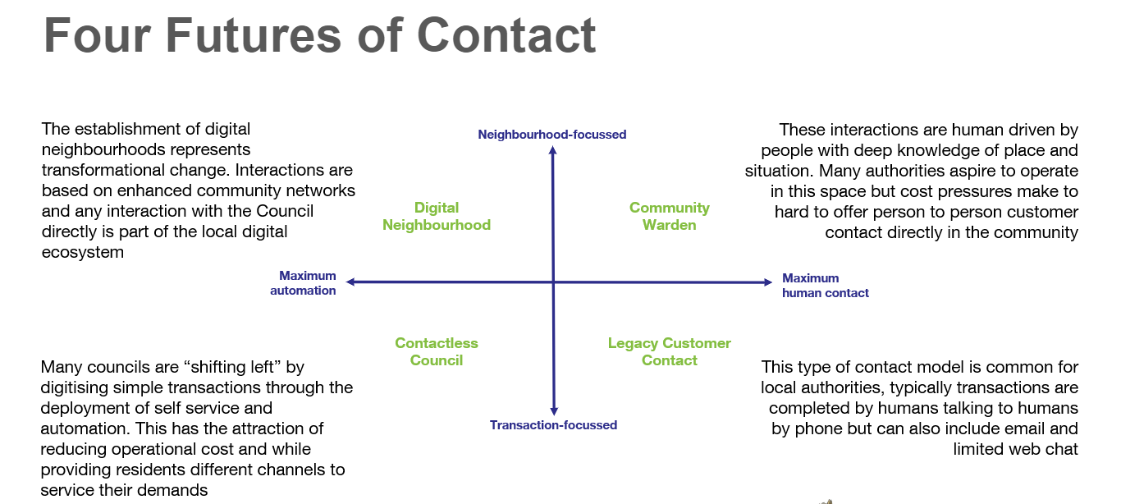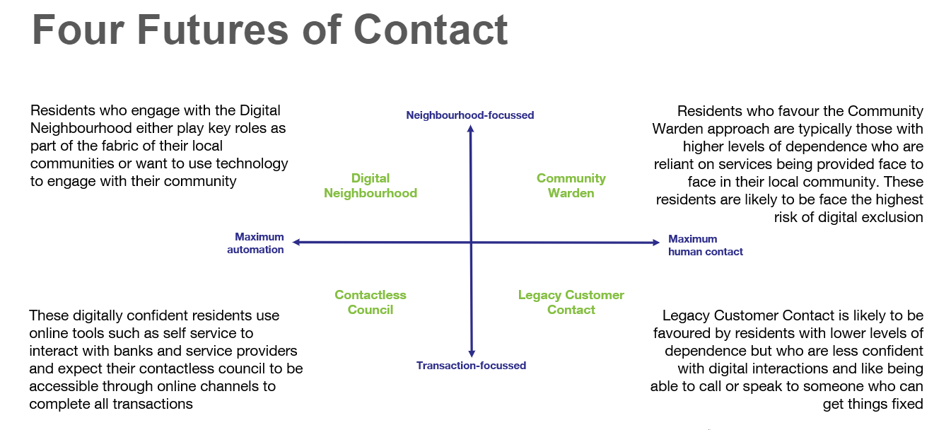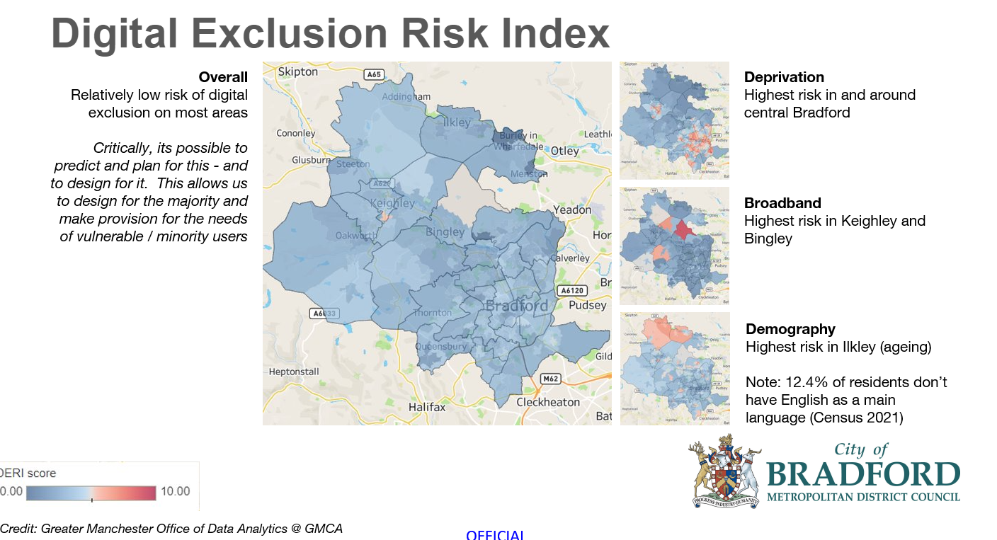

4.6 Do you need further evidence?

No

Section 5: Consultation Feedback

5.1 Results from any previous consultations prior to the proposal development.

Previous consultation includes a staff May 2023 which informed the development of the Programme.

Voice Automation

PWC reviewed existing data to identify three potential areas for voice automation.
They estimated potential benefit ranges by applying our experience from other authorities.

PWC engaged with our ICT and service teams to verify the following high level assumptions:
- AWS Connect technology will be put at the end of your IVR, rather than replace your telephony.
- main contact centre systems is Civica 360
- main Revs & Bens software is Northgate.

In addition, it was assumed that:
- Capacity released through reduction in calls can be translated into cashable savings through FTE release / reduction
- No redundancy costs will be incurred due to staff turnover rates
- ICT capacity and capability is available to enable implementation, from systems and access to enabling go-live
- Procurement capacity is available to facilitate quick access to GCloud suppliers
- Call listening and analysis can be undertaken alongside your contact teams to refine the benefits case and go into detail around the types of calls received by the Council

Customer Contact

PWC found that our current contact management processes are fragmented, workflows have not been optimised and user experiences are inconsistent.
Based on similar work with other authorities, a possible 10-15% of baseline FTE effort can be saved through a combination of the following cost reduction levers. Based on an initial view of contact volumes, this would represent a ROI of 3:1, although further work to confirm volumes and types of contact was carried out to verify the assumptions.

5.2 The departmental feedback you provided on the previous consultation (as at 5.1).

The Head of Transformation and Change has provided updates as to the reasons for the changes to CMT and consultation will continue to take place during the Programme.

The Programme Manager will ensure that any projects within the Programme requiring specific changes/alignments to staffing structures within the respective service will ensure that the Trade Unions will be consulted as a part of this process.

5.3 Feedback from current consultation following the proposal development (e.g. following approval by Executive for budget consultation).

It is proposed that consultation with representatives from service users from will be managed through the individual project boards within the programme. In additional all staff will be consulted at the appropriate stages, requesting feedback through surveys and focus groups where appropriate. Where possible service users will be included in any consultation to changes which may affect them directly for example the development of customer contact web forms. It may be that we ask a few citizens to give us feedback on their experience of using it before going live – this will be done through specific Resident User Focus groups or this purpose. The programme and any subsequent budget set for this Programme may be subject to change following the outcomes of these consultations and any recommendations

5.4 Your departmental response to the feedback on the current consultation (as at 5.3) – include any changes made to the proposal as a result of the feedback.

The Transformation and Change Programme Manager will attend the Customer Contact Programme Board and will provide regular formal updates through the programme on any issues arising from consultations taken / taking place as a result.

Greater scrutiny of functional and non-functional requirements from both the staff and citizen user perspective to ensure the Council is procuring goods and services that uphold and support the Public Sector Equality Duty and that delivery planning is done in conjunction with staff led groups who can inform and support optimum results for the transition on the technology being implemented as part of this Business Case.

There is a need for a Customer Charter for Customer Contact to be produced that meets the needs of all users with protected characteristics.

A robust Communications Strategy will be implemented during the life cycle of the programme.

